**NAME: NISHA K**

**REG: NO: 192411231**

**EX:NO:1**

Create a simple cloud software application and provide it as a service using any Cloud Service Provider to demonstrate Software as a Service (SaaS).

**AIM:**

To create and deploy a simple cloud-based software application for the Property Buying & Rental process using Zoho Creator and provide it as a Software as a Service (SaaS) to users.

**PROCEDURE:**

1. Log in to Zoho.com and access the Zoho Creator platform.
2. Create a new application and provide a suitable name (e.g. Property Buy & Rent Portal).
3. Design the application by adding necessary forms (Property details, User registration, Booking) and reports for data visualization.
4. Configure and deploy the application on the Zoho cloud platform.
5. Share the application link with users, enabling them to access the service directly via the internet.

**OUTPUT:**

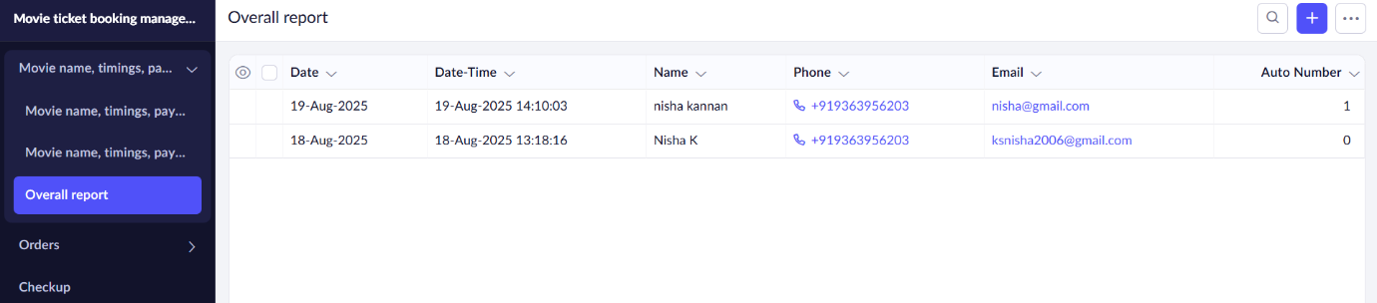

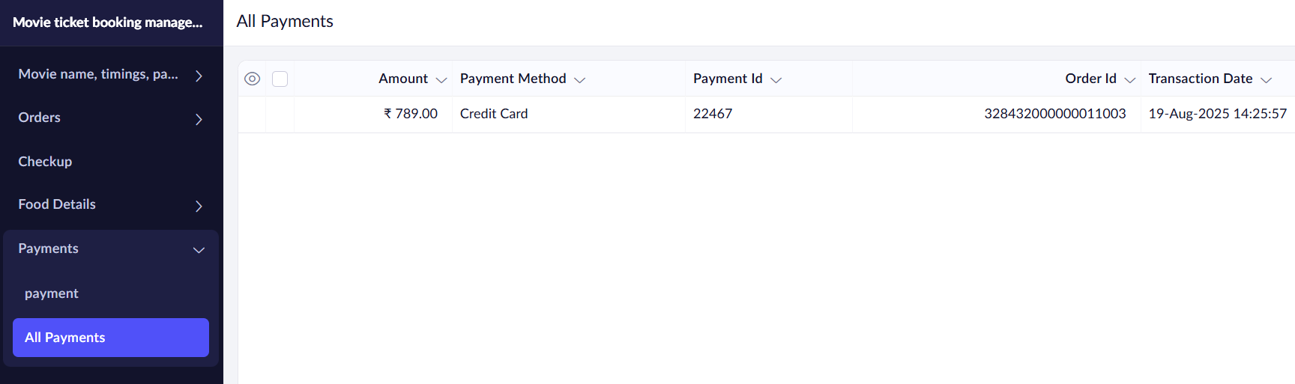



**RESULT:**

A cloud-based Property Buy & Rent Application was successfully created and deployed using Zoho Creator. Users can access the application via the internet without installing any software, thereby demonstrating the concept of Software as a Service (SaaS).